Times of Masses & Confessions during the Year
Sundays
Vigil Mass
Saturday 6 p.m.
Sunday
9.30 a.m. 11 a.m. (Choir) 12.30 p.m.
Weekdays
7.30 a.m. 8.30 a.m. 11.30 a.m. 12.45 p.m. & 5.30 p.m.
Holy Days
Vigil Mass 5.30 p.m.
7.30 a.m. 8.30a.m. 11.30 a.m. 12.45 p.m. & 5.30p.m.
Confessions

Weekdays
11.00 a.m. - 1.00 p.m. & 4.00 p.m. -5.00 p.m.
Saturdays
11.00 a.m. - 1.00 p.m. & 4.00 p.m. -5.00 p.m.

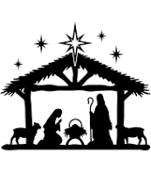
Happy Christmas
Christmas Timetable
2023
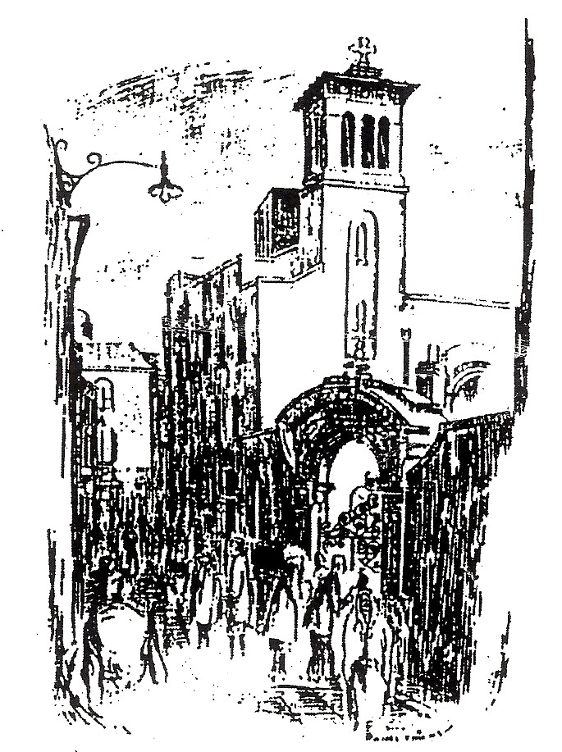
St. Teresa’s Church
Clarendon Street, Dublin 2
St. Teresa’s Clarendon Street
Christmas Timetable 2023
Tel: 01 671 8466 / www.clarendonstreet.com

Monday 18th December
Masses: 7.30a.m. 8.30 a.m. 11.30 a.m. 12.45 p.m. & 5.30 p.m.
Confessions: 11.00 a.m. - 1.00 p.m. & 4.00 p.m. -5.00 p.m.
Tuesday 19th December
Masses: 7.30a.m. 8.30 a.m. 11.30 a.m. 12.45 p.m. & 5.30 p.m.
Confessions: 11.00 a.m. - 1.00 p.m. & 4.00 p.m. -5.00 p.m.
Wednesday 20th December
Masses: 7.30a.m. 8.30 a.m. 11.30 a.m. 12.45 p.m. & 5.30 p.m.
Confessions: 11.00 a.m. - 1.00 p.m. & 4.00 p.m. -5.00 p.m.
Thursday 21st December
Masses: 7.30 a.m. 8.30 a.m. 11.30 a.m. 12.45 p.m. & 5.30 p.m.
Confessions: 11.00 a.m. - 1.00 p.m. & 4.00 p.m. -5.00 p.m.
Friday 22nd December
Masses: 7.30 a.m. 8.30 a.m. 11.30 a.m. 12.45 p.m. & 5.30 p.m.
Confessions: 11.00 a.m. - 1.00 p.m. & 4.00 p.m. -5.00 p.m.

Saturday 23rd December
Morning Masses: 7.30 a.m. 8.30 a.m. 11.30 a.m. & 12.45 p.m.
Confessions: 11.00 a.m. - 1.00 p.m. & 4.00 p.m. -5.00 p.m.

Sunday 24th December (Christmas Eve)
Masses: 9.30 a.m. 11 a.m. (Choir) 12.30 p.m.
Vigil Mass 6 p.m.
Carol Service 8 p.m.
Christmas Mass 8.30 p.m.

Monday 25th December- Christmas Day
Masses: 9.30 a.m.11.00 a.m. (Choir) & 12.30 p.m.
No Evening Mass

Tuesday 26th December - Feast of St. Stephen
Masses: 11.30 a.m.
No Confessions

Wednesday 27th December – Feast of St. John the Evangelist
Masses: 11.30 a.m. 12.45 p.m.
No Confessions

Thursday 28th December - Feast of the Holy Innocents
Masses: 11.30 a.m. 12.45 p.m. & 5.30 p.m.
Confessions: 11.00 a.m. - 1.00 p.m.

Friday 29th December
Masses: 11.30 a.m. 12.45 p.m. & 5.30 p.m.
Confessions: 11.00 a.m. - 1.00 p.m.
Saturday 30th December
Masses: 11.30 a.m. 12.45 p.m.
Vigil Mass 6.00 p.m.
Confessions: 11.00 a.m. - 1.00 p.m. & 4.00 p.m. -5.00 p.m.
Sunday 31st December – Feast of the Holy Family
Masses: 9.30 a.m. 11 a.m. (Choir) 12.30 p.m.

Monday 1st January- Mary, the Mother of God
Masses: 11.30 a.m. only
No Confessions

